ENTRY REPORT

What does the team intent to do?

Who is in the team/ basic information?

The team consists of a class of students of the “applied sciences” option of the Institut de la Providence in Ciney. We are six students

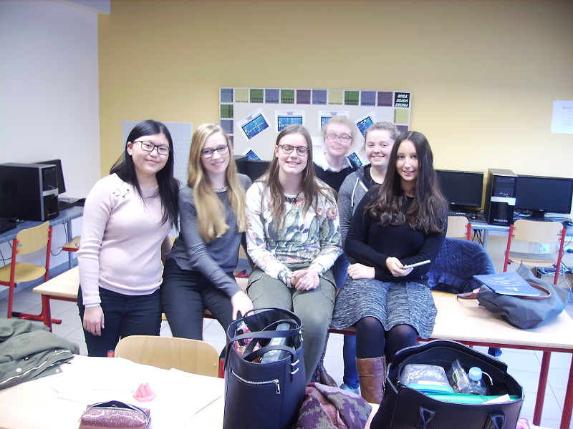

From left to right : Meily, Chloé, Perrine, Camille, Cécile, Eugénie. We are very happy to have been selected for the project

PROGRESS REPORT

Table of Contents

I. PROGRESS STATEMENT FOR TEAM PROFILE
II. TASK LIST
III. DETAILED PROJECT STATUS

- Progress statement for team profile

Describe the status of your project (lines 10-15)
- Division of the labor
The labor is mainly divided in three branches : The first one (Managed by Chloé and Meily) is the communication, either with the persons at CanSat, the media (newspapers, social media..), but also with any other persons who could help us in achieving the mission, for example our classmates from the Informatics option who will help us a little bit with the software related aspects.
- Which equipment and materials do you use? Why?
We essentially use the basic T-minus CanSat package which will be extended by some Arduino-board compatible sensors and components for the main missions, because this will allow us to easily stay within the budget for the project. The “hardware” will use all round objects (beverage cans, nuts and bolts, nylon sheet for the parachute, aluminium wire for the antenna extension) for the same reason.
- We hope that we can use the 3D printer that our school has just purchased.
- Status of the core mission
The hardware of the core mission, the temperature and pressure probes are on the primary mission board, and we now work with our informatics classmates to read, check and calibrate the data.
- Status of the secondary mission
For the secondary mission we purchased the probe it needs and we are designing and wiring the secondary mission the next days.
- Have you measured some data yet? If so, which? What is the result?
We measured the raw data from the temperature and pressure probes, through radio-frequency communication. The temperature probes are responding, but the pressure is more difficult to test. We have to think about a pressure measuring method.
- How do you sensitize the other pupils of your school to the action?
Essentially by communicating by using the new school Intranet, which will make this quite easy.

- Task list

Prerequisites
General planning, getting essential skills | DONE/DELAYED/IN PROGRESS
Rough testing and feasibility of the mission(s) | DONE/DELAYED/IN PROGRESS
Collecting necessary materials | DONE/DELAYED/IN PROGRESS
Communication/Media attention
Getting a list of contacts | DONE/DELAYED/IN PROGRESS
Social media and dedicated Internet site | DONE/DELAYED/IN PROGRESS
Building the CanSat
Assembling all components on the plates | DONE
Stacking the plates /Fitting in Can | DONE
Engineering / constructing / testing the parachute | DONE
Engineering / constructing the antenna | IN PROGRESS
Additional items (Power supply, master switch…) | DONE

- Detailed project status

Primary mission

The basic primary mission plate has been assembled and rough-tested. The procedure is described here:

After setting up the software and RF communication, we started to read data from the sensors from within the classroom, at a temperature of approximatively 20 degrees Celcius. Then we put the Cansat with the primary mission outside. The temperature was approximatively 0 degree. A significant change in the transmitted values is a sign of success. Checking this was very important for us, since it opens the way to the achievement of the complete CanSat Mission. Since the results obtained weren’t too accurate, we needed to build calibration curves of the temperature sensors. As expected, the results are more reliable, although we are confronted with differences from one day to another. The pressure probe seems reliable. We tested this by comparing the calculated data (from Arduino forums) to QFE (non altitude-corrected atmospheric pressure).

Secondary mission

The secondary mission plate has been assembled and the combined humidity/temperature sensor has been thoroughly checked. This sensor (a DHT11) was hard to get working, and it was really difficult to find accurate solutions for the problems. It now gives reliable data, but sometimes it “hangs” and outputs no value. The reactivity is also slightly under expectations : it takes some times to recover from high humidity situations and from high temperatures.

Assembling the CanSat

To save space, we assembled the plates in the following order, from bottom to top :
- The transceiver
- The main board
- The secondary mission
- The Primary mission.

To ensure rigidity and solidity, we used the steel rods to assemble these parts together, but instead of using nuts between the plates, we’ve used aluminium rod spacers, this in order to be able to assemble/disassemble the stack quickly, if needed. We only need to unscrew a few bolts.

The battery compartment is at the bottom of the assembly, under the base terminating plate. We made an additional ending plate from steel, which will be used to tighten the battery and fix the assembly to the can.

The upper end consists of an endplate with a parachute hook.

The container consists of a standard 33cl beverage can, so that we are sure we do not exceed the physical size requirements. The upper lit has been cut off, in order to put the assembly inside. It is then fixed by the steel bottom plate to the bottom of the can. A lid from a second can covers the upper open end, to make the structure more rigid, and to avoid cutting edges. Holes have been drilled in the can, to allow the mission plates to be in contact with the outside environment.

An additional hole is for the onboard antenna, and another to access the master switch.

Funding

We use the budget from the cansat project to buy the equipment. In order to avoid to exceed the budget, we make use of everyday materials, like beverage cans, modelling aluminium rods for the antenna, switches and components from obsolete computers

Outreach

DESIGN DOCUMENT

Table of Contents

I. INTRODUCTION
I.1. Team organization and roles
I.2. Mission objectives

II CANSAT DESCRIPTION
II.1. Mission overview
II.2. Mechanical / structural design
II.3. Electrical design
II.4. Software design
II.5. Recovery system
II.6. Ground support equipment

III. PROJECT PLANNING

III.1. Time schedule of the Cansat Preparation

III.2. Resource estimation
III.2.1. Budget
III.2.2. External support

III.3. Test plan

- OUTREACH PROGRAMME

V. REQUIREMENTS

ATTACHMENTS

I. INTRODUCTION

I.1. Team organization and roles

- Name and surname of the persons who are in the team (teacher, student, foreign help)
Students: Saudemont Chloé, Grégoire Perrine, Thielen Eugénie, Lian Meily, Ottelet Cécile, Finfe Camille
Teacher : Mr Schraverus
Foreign help : our classmates (students in computer science)
- What is their own interest in the CanSat project?
Learn new things linked with our scientific lessons
Discover things in subjects that we don’t really know.
- What do they bring to the project (their specific skills)
Chloé: precise and has good English
Perrine: serious and motivated
Eugénie: deft with her hands
Meily: serious and precise
Cécile: good at dividing the different tasks in a group
Camille: creative
- On what part of the project each member is working?
Camille and Eugénie soldered the primary mission plate.
Perrine and Chloé soldered the secondary mission plate.
Cécile and Meily cut the material for the parachute.
Eugénie sewed the parts of the parachute.
Perrine cut the can.
Meily and Chloé did the antenna.
- How much time each member will he spend on the project?
We spent at least three hours per week on the project.

I.2. Mission objectives

What is the purpose of the secondary mission?

It has to measure the temperature and humidity.
Why have you chosen this mission? What is the reason?
By looking at airplane condensation clouds, we were wondering if there was a correlation between the persistence of these clouds and the humidity. Burning kerosene releases water vapor, but it might not be the only factor in making these clouds appear. Probably the small particles released by kerosene burning act as condensation nuclei. This subject is quite complex, since the cold air at high altitude contains almost no moisture. Will the expected increase of air traffic have an influence on the cloudiness in the future?
Where are you in the mission development?
We are able to collect (relative) humidity and temperature, and in situ we will be able to check visibility conditions.

II CANSAT DESCRIPTION

II.1. Mission overview

What is the mission of your CanSat (step by step)?

The parachute has to open after the launching,

The primary mission has to measure the temperature and the pressure,

The secondary mission has to measure the humidity,

The computer receives the data from the sensors and transfers it to the radio,

The radio has to send waves.

II.2. Mechanical / structural design

How is your CanSat designed? (Inside and outside)

Inside: the different plates are placed on top of each other. From the bottom to the top, there is the power supply and the master switch, the transceiver plate, the main board, the secondary mission plate and finally the primary mission plate. The different plates are very strongly linked by rods passing through the corner of each plate. Aluminium spacing tubes prevent crushing by tightening the retaining bolts too much.

The assembly is fixed to a base steel plate, by means of the rods. This steel base plate is firmly attached to the bottom of a beverage can. Between this plate and the lower end plate lies the battery. The size of the battery compartment can be slightly modified, in order to accept different battery sizes. Since the battery is quite heavy and subject to g-forces, it is secured by tightening the lower plate.

The sensors must be in contact with the outside world, so holes are drilled all over the can, on the mission plates level. since the can is metallic, the onboard antenna passes through a specific hole in the can.

The main job of the upper plate is to attach the parachute.

II.3. Electrical design

Description of the electrical design of each part of the CanSat

The mission boards have double rows of connectors on three sides. These rows of connectors are wired to the two adjacent rows of holes. This makes connection of the sensors easy, as long as the signal pin of the sensor lies aside, and not between the power supply pins. We’ve use this architecture to avoid as possible to solder connecting wires.

The primary mission plate consists of an LM35 temperature sensor, a thermistor/resistance couple, and a pressure sensor. The Pressure sensor is connected to the analog pin #6, the thermistor to analog pin #0, and the LM35 sensor to the analog pin #4, by blue wire. The +5V and the ground are connected to the closest supply points by code colored wire (red for +, black for ground).

The secondary mission plate is connected in the same way, the signal pins of the DHT sensor connected to the specific Arduino/T-minus A5 connector

II.4. Software design

Which software do you use and why?

We use the software C++ Arduino because it is (relatively) simple and it is provided with the kit. We tried to make use of dedicated libraries when possible, and to “factorize” code as possible, e.g. make use of functions, in order to keep the main “loop()” function as simple as possible.

The sketches are structured as follows :
- includes
- functions
The functions essentially convert rough data (0-1023 8 bit value, for example) to useable data (temperature, humidity, … )
they thus essentially receive a parameter and convert it before returning the calculated value.
The functions either use home made programming or code from Arduino tutorials. Often there is more tha one function for a specific purpose : for example, the temperature got from the LM35 sensor is either calculated by using the fabric specification sheet and an calibration equation.
- initialization
The system setup is made in this section. Essentially the transmission rate and pin assignments.
- loop
The core of the program. Since most of the coding lies inside the functions, the loop section is quite simple, and essentially consist of time management (delay) and outputting the function results to the monitor.

II.5. Recovery system

We choose a colored, round shaped parachute with a center hole, for stability. It was hard to design, since it consists of twelve gores sewed together. We used scientific calculations to design the shape and size of the gores, and thus the parachute. In addition, our rake Yagy antenna is directional so if the CanSat is still sending data, we may use the signal strength. to recover the can. Ideally, we need two or more receptors to use goniometry, but this is still an idea.

II.6. Ground support equipment

We have two portable computers (a work computer and a backup) and the transceiver with the Yagi antenna. We will also take a telescope / far-viewers.

III. PROJECT PLANNING

III.1. Time schedule of the Cansat Preparation

 | Designed | Prototyped | Constructed | Tested
Primary mission
Electronics | V | V | V | V
Mechanics | V | V | V | V
Software | V | V | V | V
Secondary mission
Part 1 | V | V | V | V
Part 2

III.2. Resource estimation

III.2.1. Budget
The budget of this project is covered by the CanSat organization, our budget will not exceed this budget because we use inexpensive components and reused materials. The current expenses are of about 200€, the basic CanSat kit not included.

III.2.2. External support
The school has budgeted some materials that fall within the scientific courses. So this can be considered as external support, out of the scope of the CanSat funding. The other support if from the informatics students, the time spent on the project being part of their educational program (Programming languages course).

III.3. Test plan

- CanSat : The electronics have been tested, as well as the programming.

- Parachute : Tested on smooth opening and approximate descent speed, some additional testing will be done in the next days to ensure descent speed requirement. The parachute is easy to modify, so descent speed could be adapted if necessary.

- Antenna/Reception : Tests show some problems with cross-obstacle transmission, but VFH waves have a near optic travel way, and the CanSat is not supposed to get out of sight. The antenna can be trimmed if necessary, in case of poor reception, the antenna design can be easily modified, by telescopic design of the half-wave receptor dipole and the pre-drilled holes if the bom.

- OUTREACH PROGRAMME

V. REQUIREMENTS

Characteristics | Figure | Complies
 |  | V
Mass of the CanSat |  | V
Diameter of the CanSat |  | V
etc.

ATTACHMENTS

Working documents and pictures can be found on the following link :

http://www.ipciney-info.be/cansat/documents

